CS6360.004 Fall 2018

Assignment 2 – Install a Database

(Have attached the images separately too)

1. Using **Microsoft SQL Server** with **SQL Server Management Studio**.

2. Ran the script given by the Professor. The below image is a screenshot showing connectivity to the Company database, including the list of tables:

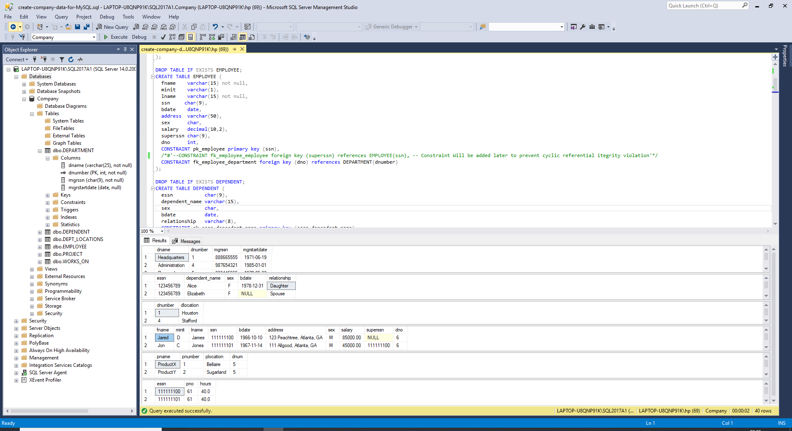

3. Ran below queries:

a) Inserted my name ‘Amith Kumar Matapady’ into the ‘Company’ database with social security number of 111111111 and department number 6 and a few other details:

Query –

Use Company;

Insert into EMPLOYEE(fname, lname, ssn, bdate, address, sex, salary, dno)

Values ('Amith Kumar', 'Matapady', '111111111', '09-22-1992', '3560 Alma Road, Dallas, TX', 'M', '42000', '6');

select * from employee where ssn=111111111;

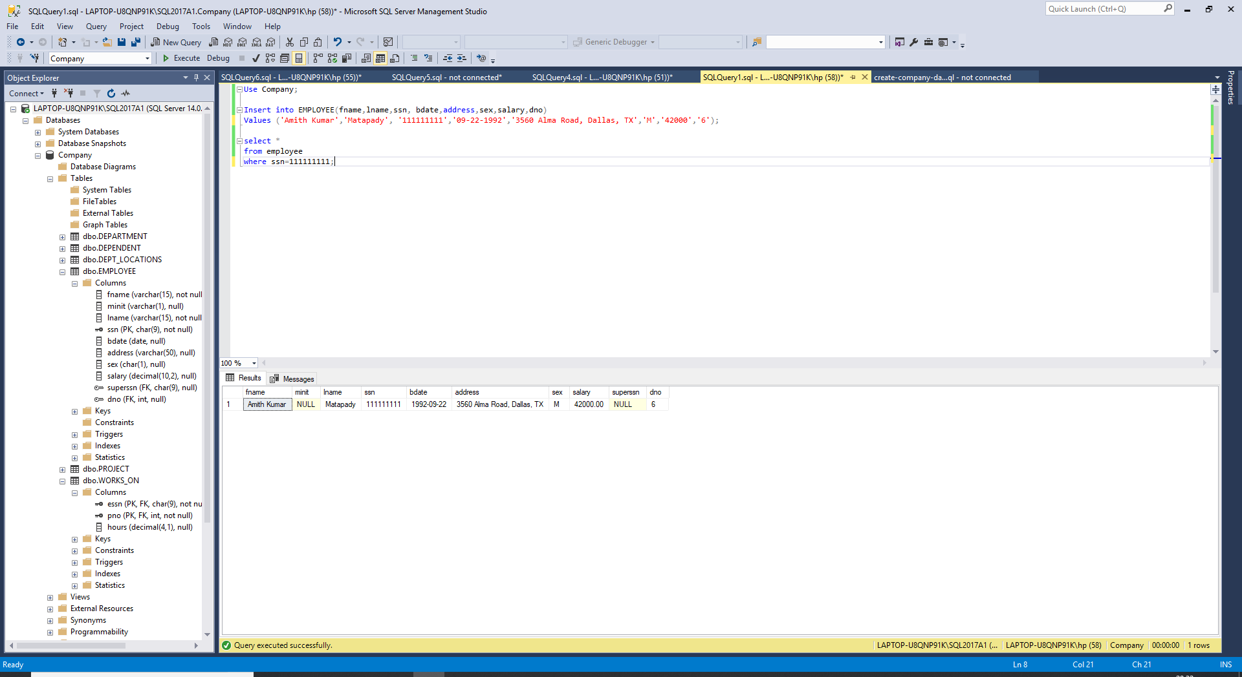

b) Updated my employee record to show 111111100 as my supervisor:

Query –

Use Company;

Update EMPLOYEE

set superssn=111111100

where ssn=111111111;

select * from employee where ssn=111111111;

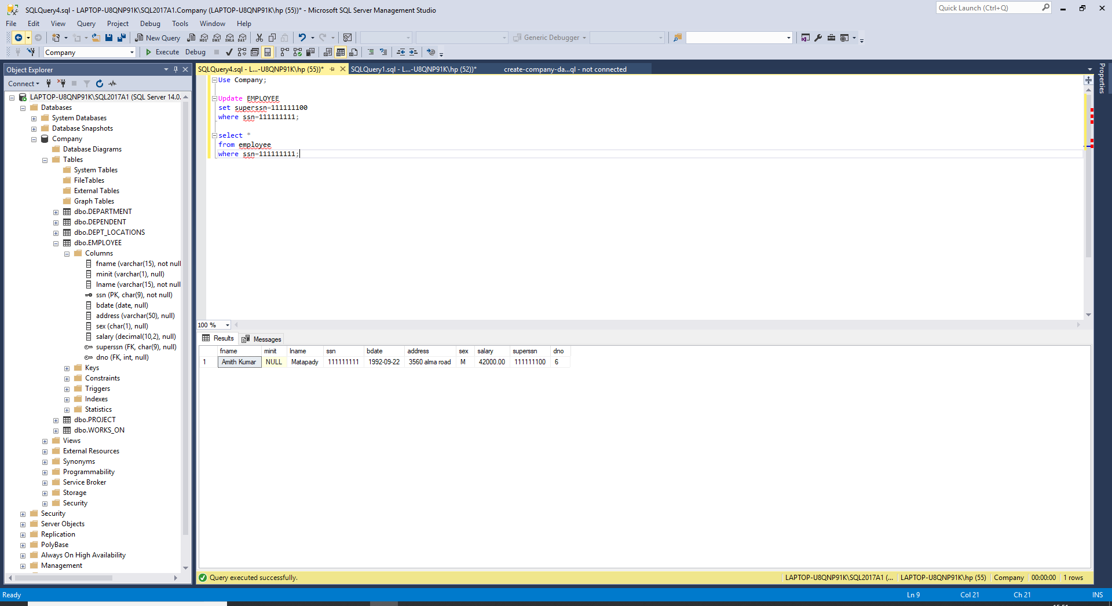

c) Ran a query to show all employees who work for either supervisor Jared D. James or for supervisor Evan E. Wallis:

Query –

use company;

select * from employee

where

(superssn=(select ssn from employee where(fname='jared' and minit='d' and lname='james'))

OR

superssn=(select ssn from employee where(fname='evan' and minit='e' and lname='wallis')));

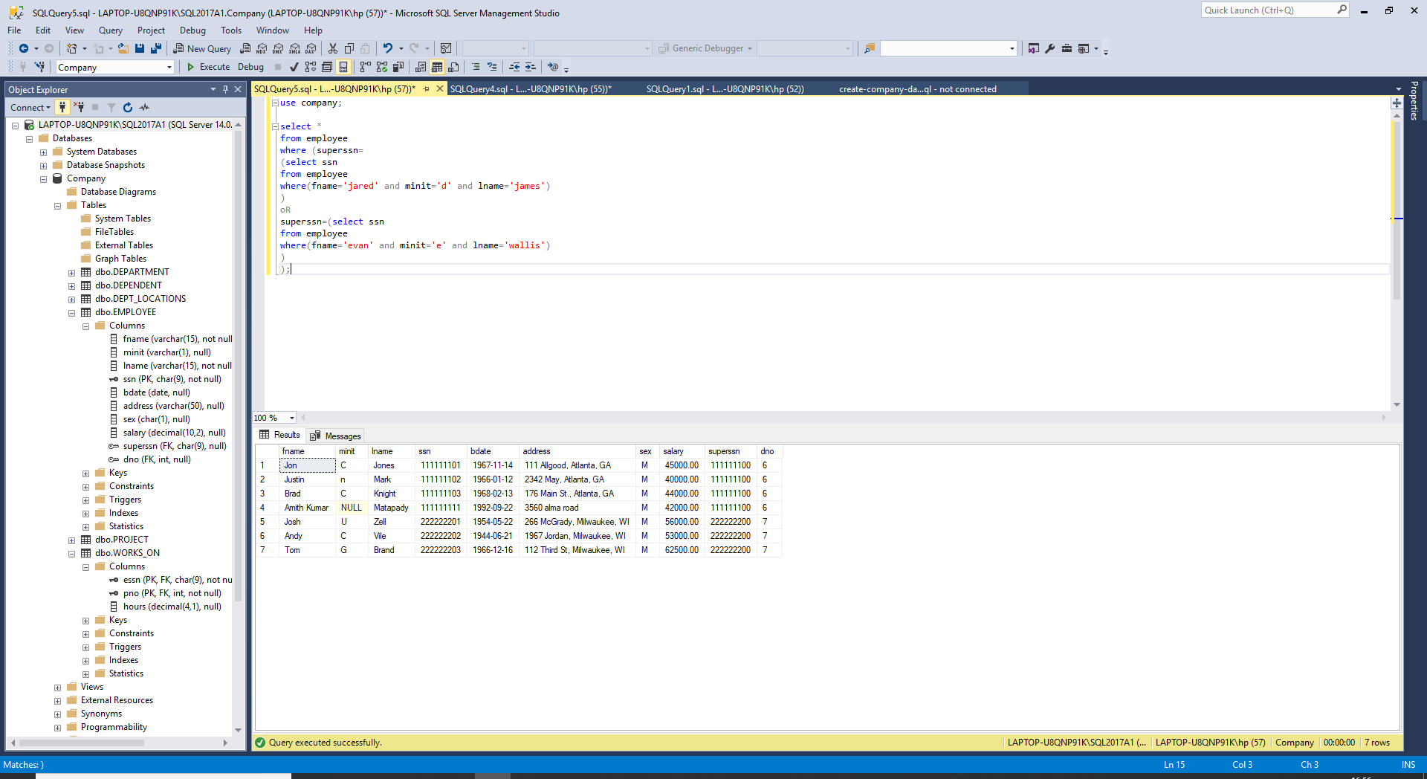

d) Ran a query to show all employees who make more than $50,000 per year, who are over 30 years old, and who live in Wisconsin(WI):

Query –

use company;

select *

from EMPLOYEE

where (salary>50000 and (address like '%WI%') and (bdate < '19880916'));

